Chutes and Ladders

# Body

Heat escaping the solid Earth’s surface indicates a dynamically cooling planet. Surface heat flow databases (Hasterok & Chapman, 2008; Lucazeau, 2019; Pollack et al., 1993) enable investigation *everything is related, but nearer things are more related* (Krige, 1951; Matheron, 1963). The spatial (dis)continuity of surface heat flow represents the areal extent of geodynamic processes and their interactions. For example, patterns of consistently low surface heat flow outline the areal extent of cratons (Figure 1)

## Figures

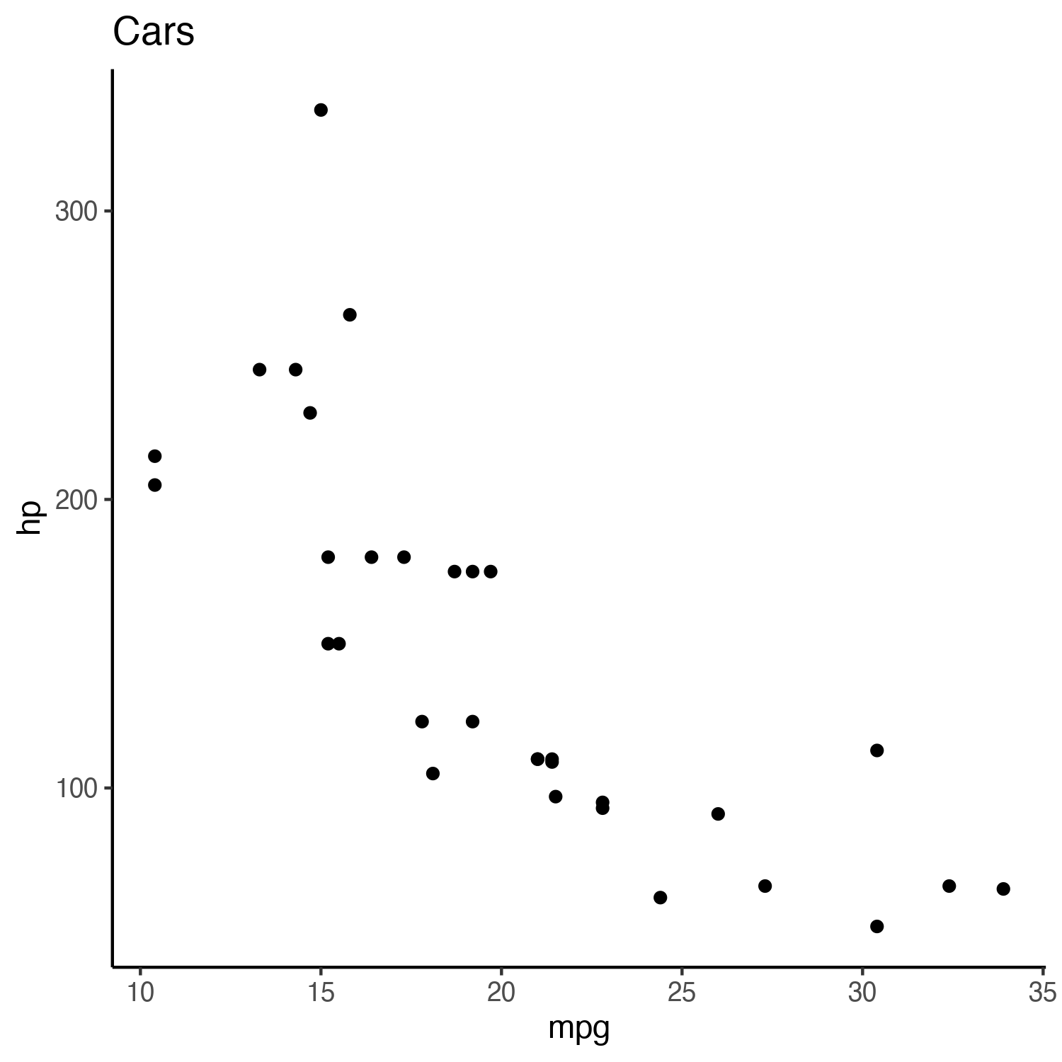

Figure 1: A cars plot

## Equations

Like Lucazeau (2019), we exclude 4790 poor quality observations (Code 6 = D) from our analysis. We further remove 350 data points without heat flow observations and two without geographic information. Multiple observations at the same location are parsed to avoid singular covariance matrices during Kriging:

$$\begin{matrix}f\left(X_{i}^{q},Y_{i}^{q}\right) & = \\ X_{i}^{q}>Y_{i}^{q} & →z_{i}=x_{i} \\ X_{i}^{q}<Y_{i}^{q} & →z_{i}=y_{i} \\ X_{i}^{q}=Y_{i}^{q} & →z_{i}=RAND\left(x_{i},y_{i}\right)\end{matrix} \left(1\right)$$

where $X_{i}^{q}$ and $Y_{i}^{q}$ represent the quality of each duplicate observation pair at location $i$, $RAND$ is a random function that selects either the observation $x_{i}$ or $y_{i}$, and $z_{i}$ stores the observation selected by $f\left(X_{i}^{q},Y_{i}^{q}\right)$. The final dataset used for Kriging has $n=$ 55274 observations after parsing $n=$ 32430 duplicate observation. We use Equation 1 to

## Code

You can link to code at <https://doi.org/10.17605/OSF.IO/CA6ZU>.

+proj=robin +lon_0=-155 +lon_wrap=-155 +x_0=0 +y_0=0  
+ellps=WGS84 +datum=WGS84 +units=m +no_defs

## Tables

Table 1: Car ($mWm^{−2}$) observations

|  |  |  |  |
| --- | --- | --- | --- |
| n | mean | tot.hp | tot.cyl |
| 32 | 20.09062 | 4694 | 198 |



Figure 2: The total number of cylinders is 198 $mWm^{−2}$ and highly skewed right

# Lists

This study uses

1. Inconsistent patterns
2. Kriging and similarity
3. For testing hypotheses
4. Focused improvements
5. Improving Kriging

# Open Research

All data, code, and heat flow interpolations can be found at https://doi.org/10.17605/OSF.IO/CA6ZU, the official Open Science Framework data repository. All code is MIT Licensed and free for use and distribution (see license details, sec. 5.1.1).

We thank D. D for providing the NGHF. This work was supported by the National Science Foundation grant OIA1545903 to M. Kohn, S. Penniston-Dorland, and M. Feineman.

# References

# Appendix

### License

No license but a table in Table 2

Table 2: Parameters and ranges used in the optimization algorithm

|  |  |  |
| --- | --- | --- |
| Parameter | Search Domain | Units |
| Lag Cutoff (c) | [$1/3$, $1/15$] | NA |
| Lag Window (w) | [1, 5] | NA |
| Model (m) | [Spherical, Exponential] | NA |
| Sill (s) | [1, $1000\sqrt{2}$] | $mWm^{−2}$ |
| Effective Range (a) | [1, 1000] | km |
| Nugget (n) | [1, $1000\sqrt{2}$] | $mWm^{−2}$ |
| Local Search (S) | [1, 10000] | km |

Hasterok, D., & Chapman, D. (2008). Global heat flow: A new database and a new approach. In *AGU fall meeting abstracts* (Vol. 2008, pp. T21C–1985).

Krige, D. G. (1951). A statistical approach to some basic mine valuation problems on the witwatersrand. *Journal of the Southern African Institute of Mining and Metallurgy*, *52*(6), 119–139.

Lucazeau, F. (2019). Analysis and mapping of an updated terrestrial heat flow data set. *Geochemistry, Geophysics, Geosystems*, *20*(8), 4001–4024.

Matheron, G. (1963). Principles of geostatistics. *Economic Geology*, *58*(8), 1246–1266.

Pollack, H. N., Hurter, S. J., & Johnson, J. R. (1993). Heat flow from the earth’s interior: Analysis of the global data set. *Reviews of Geophysics*, *31*(3), 267–280.